STUDY DESCRIPTION AR-7
ESA-Listed Amphibian and Aquatic Reptile Visual Encounter Surveys

Draft –06/29/26

This Study Description is developed to address information gaps identified by Calaveras County Water District (CCWD) for the relicensing of its North Fork Stanislaus River Hydroelectric Project (Project).￼

Four federal Endangered Species Act (ESA) listed amphibian species and one aquatic reptile species proposed for ESA-listing have the potential to occur within the proposed Federal Energy Regulatory Commission (FERC) Project Boundary and/or stream reaches potentially affected by the Project, as identified in the Pre-Application Document (PAD): Yosemite toad (Anaxyrus canorus), foothill yellow-legged frog (Rana boylii; South Sierra Distinct Population Segment [DPS]), California red-legged frog (Rana draytonii), Sierra Nevada yellow-legged frog (Rana sierrae), and northwestern pond turtle (Actinemys marmorata). Two of these have been documented within the PAD’s aquatic resource Assessment Area (i.e., the FERC Project Boundary, Project-affected stream reaches, and a 0.25 mile buffer)—foothill yellow-legged frog and Sierra Nevada yellow-legged frog—while the other three have been documented outside, but within 5 miles, of the aquatic resources Assessment Area.

This study will be conducted in conjunction with Study AR-6 (Special-status Amphibian and Aquatic Reptile eDNA Sampling).

STUDY AREA

The Study Area includes safely accessible areas within 0.25 mile of the proposed FERC Project Boundary, which includes the project impoundments (i.e., North Fork Diversion Dam impoundment, New Spicer Meadow Reservoir, Beaver Creek Diversion Dam impoundment, and McKays Point Reservoir). The Study Area also includes stream reaches downstream of project dams that have the potential to be affected by Project operations or activities, including portions of Highland Creek, North Fork Stanislaus River, Beaver Creek, and Stanislaus River.
The elevation range of the Study Area is from approximately 6,700 to 1,100 feet above mean sea level.

Survey Locations

General survey locations and the target species are listed in Table 1, which includes the waterbody, general location of the site, and the proposed site length (if applicable); biologists will determine the exact location and extent of the site based on accessibility, habitat suitability, and safety. Survey locations may target multiple ESA-listed species where suitable habitat is co-occurring (e.g., meadow habitat may target Yosemite toad and Sierra Nevada yellow-legged frog). Approximate locations are shown in Figure 1.

Table 1. General survey locations for Study AR-7, ESA-listed Amphibian and Aquatic Reptile Visual Encounter Surveys.
Waterbody | General Survey Location (Approximate River Mile¹) | Type | Approximate Site Length (mile) | Target Species
 |  |  |  | YT | SNYLF | CRLF | FYLF | NWPT
North Fork Diversion Impoundment | Accessible shoreline areas with suitable meadow/ wetland habitat | Reservoir | NA² | X | X
New Spicer Meadow Reservoir | North Fork Diversion Tunnel outlet channel | Stream | 0.20³ |  | X
New Spicer Meadow Reservoir | Accessible shoreline areas with suitable meadow/ wetland habitat | Reservoir | NA² | X | X
Highland Creek | Downstream of New Spicer Meadow Reservoir (HC 5.5) | Stream | 0.25 |  | X |  |  | X
North Fork Stanislaus River | North Fork Stanislaus River or Duck Creek upstream of North Fork Diversion impoundment (NF 33.3) | Stream | 0.25 | X | X
North Fork Stanislaus River | Downstream of North Fork Diversion Dam (NF 32.7) | Stream | 0.25 |  | X
North Fork Stanislaus River | Pioneer Walking Bridge upstream of confluence with Highland Creek (NF 27.8) | Stream | 0.25 |  | X |  |  | X
North Fork Stanislaus River | Wakalu Hep Yo Campground Area (NF 16.2) | Stream | 0.25 |  | X | X | X | X
North Fork Stanislaus River | Upstream of Boards Crossing Road (NF 14.5) | Stream | 0.25 |  | X | X | X | X
North Fork Stanislaus River | Stanislaus River Day Use Area near Lava Bluffs Trailhead (NF 11.2) | Stream | 0.25 |  | X | X | X | X
North Fork Stanislaus River | Downstream of McKays Diversion Dam (NF 7.7) | Stream | 0.25 |  | X | X | X | X
Beaver Creek Diversion Impoundment | Accessible shoreline areas with suitable habitat | Reservoir | NA² |  |  | X |  | X
Beaver Creek | Downstream of Beaver Creek Diversion Dam (BC 3.0) | Stream | 0.25 |  | X | X | X | X
Stanislaus River | Near confluence of Collierville Powerhouse Tailrace | Stream | 0.25 |  |  |  | X | X
Notes: CRLF = California red-legged frog; FYLF = foothill yellow-legged frog; NA = not applicable; NWPT = northwestern pond turtle; SNYLF = Sierra Nevada yellow-legged frog; YT = Yosemite toad;
¹ For survey locations in stream reaches, approximate river miles are provided.
² Reservoirs or impoundment shoreline surveys will include up to 0.25 miles of combined shoreline focusing on suitable habitat for target species that is safely accessible.
³ Surveys will be conducted in the open, accessible portion of the tunnel outlet channel near the confluence with New Spicer Meadow Reservoir and Hobart Creek. Enclosed portions of the North Fork Diversion Tunnel will not be surveyed.

For Yosemite toad, additional survey locations will be evaluated using a desktop habitat assessment. For habitat to be included as a survey location it will meet the following criteria: (1) contain suitable aquatic breeding habitat for Yosemite toad; (2) be within 0.78 mile of the FERC Project Boundary and above 6,400 feet in elevation (e.g., areas around North Fork Diversion Impoundment, New Spicer Meadow Reservoir, and Spicer Reservoir Campground); (3) the breeding habitat or surrounding uplands (within 0.78 mile of the FERC Project Boundary) have the potential to be affected by routine Project operation and maintenance activities or Project-related recreation; and (4) is safely accessible with appropriate landowner approval(s). The desktop habitat assessment will use existing data including, National Wetland Inventory maps, U.S. Geological Survey 1:24,000 topographic quadrangle maps, hydrologic data, and aerial imagery.
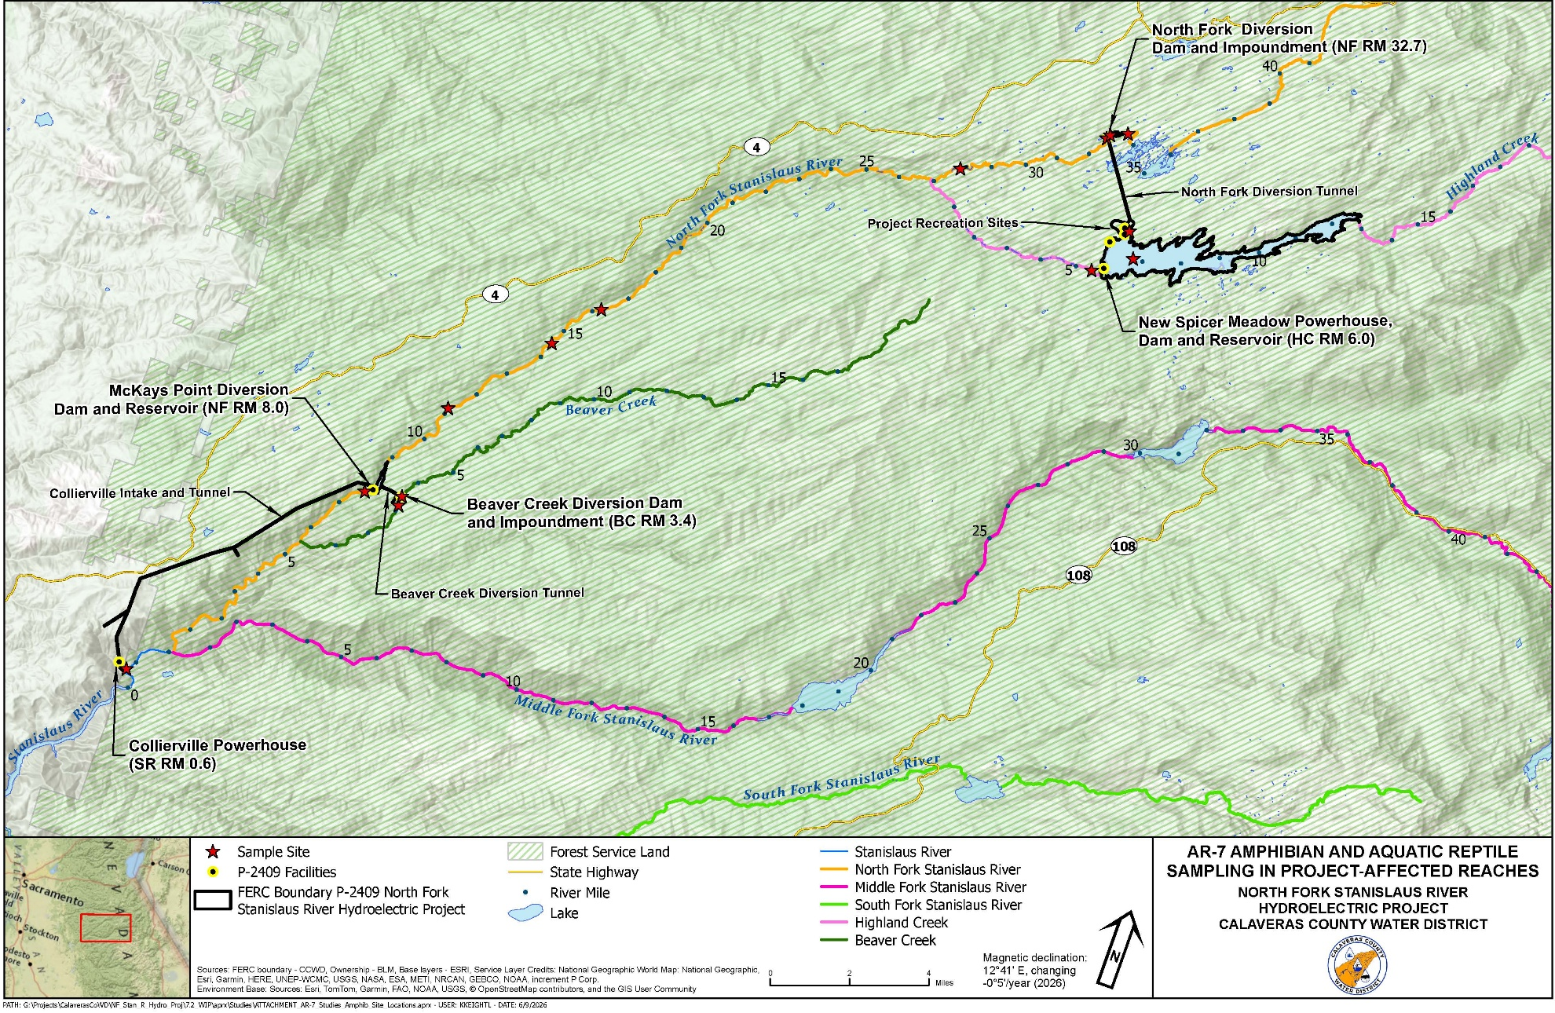
Figure 1. AR-7 Approximate Survey Locations.
STUDY METHODS

Field Survey Methods

Field surveys will include visual encounter surveys (VESs) for target species based on aquatic habitat associations and established or recommended protocols. Appropriate scientific permitting (e.g., handling permit, scientific collecting permit) for ESA-listed species will be sought from the U.S. Fish and Wildlife Service (USFWS) and California Department of Fish and Wildlife (CDFW) prior to initiating surveys.

For all target species except Yosemite toad, surveyors will conduct a total of three VESs at the survey locations included in Table 1. Exact timing for each survey will be determined based on the target species’ breeding seasons and environmental conditions (e.g., snowmelt, temperature, and accessibility) for that year. Surveys for multiple target species may be conducted concurrently based on elevational or target species ranges. For instance, the North Fork Stanislaus River near the Wakalu Hep Yo Campground Area has the potential for four target species (Table 1).

Habitat conditions will be recorded during each survey with notes relevant to each target species, such as habitat type, stream type (i.e., perennial, intermittent, or ephemeral), aquatic and terrestrial vegetation, stream gradient, stream bankfull width estimates, aquatic substrate, water temperature, stream channel characteristics, water clarity, and presence of potential predators. Additionally, during all targeted field surveys, incidental observations of all amphibian or aquatic reptile species will be noted and detailed data will be collected (e.g., location, life stage, habitat description).

Yosemite Toad. VESs will be conducted following standard protocols for Yosemite toad outlined in Brown et al. (2012) and Brown and Olsen (2013). Surveys will target the species’ breeding season when egg masses, tadpoles, and/or breeding adults could be present. One survey will be conducted targeting the species’ breeding period, concurrent with a Sierra Nevada yellow-legged frog survey.

The U.S. Department of Agriculture, Forest Service (Forest Service) and USFWS (2014 and 2017) Programmatic Biological Opinions provide the most recent formal guidance specific to Forest Service lands and a framework for survey methods to understand the distribution of Yosemite toads and Sierra Nevada yellow-legged frogs and inform potential Project effects. These Programmatic Biological Opinions require three VESs over three separate calendar years, with at least one survey during a water year where snowpack is ≥80% of normal, to determine the site is unoccupied. Biologists will coordinate with the Forest Service regarding any existing survey data for Yosemite toad. If prior surveys have been conducted, these data will be used in conjunction with this Study to make an occupancy determination, if feasible.

Foothill Yellow-legged Frog. VESs will be conducted following standard protocols for foothill yellow-legged frogs outlined in Peek et al. (2017). Three surveys will be conducted in one year between early spring and early fall to target and document all life stages of the species: adults, subadults, tadpoles, and egg masses.

California Red-legged Frog. VESs will be conducted following day survey methods described in USFWS (2005). Surveys will be conducted concurrently with surveys for foothill yellow-legged frogs at sites with suitable aquatic habitat.

Sierra Nevada Yellow-legged Frog. VESs will be conducted following standard protocols for Sierra Nevada yellow-legged frogs outlined in CDFW (2022) and using techniques described in Brown and Olsen (2013), Brown et al. (2014), and Brown et al. (2019). Three surveys will be conducted in one year between early spring and early fall (an early-, mid-, and late-season survey) to target and document all life stages of the species and to document presence of the species in and near Project-affected reservoirs and reaches. Ideally, at least one survey will be conducted during a water year where snowpack is at least 80 percent greater than normal, consistent with the Forest Service and USFWS’s guidelines for determining habitat occupancy (Forest Service and USFWS 2014, 2017).

Northwestern Pond Turtle. Methods of surveying for this species in lentic and lotic habitats will generally follow standard visual survey protocols (i.e., pedestrian surveys) for pond turtles outlined in USGS (2006) and Bury et al. (2012). Surveys will be conducted concurrently with surveys for Sierra Nevada yellow-legged frogs (where species’ range overlaps) and foothill yellow-legged frogs at sites with suitable aquatic habitat.

Analysis

Species presence and distribution data will be tabulated, summarized, and checked for quality. Habitat conditions, photographs, and other field notes collected during VESs will be used to identify suitable habitat for target ESA-listed amphibian and reptile species within the proposed FERC Project Boundary or potentially affected by the Project.

REPORTING

CCWD will analyze the results of desktop and field efforts as described above. Study data will be made available to interested parties and standard GIS shapefiles, including metadata, if developed will be provided.

SCHEDULE

CCWD anticipates the schedule for Study completion as follows:
Desktop breeding habitat assessment for Yosemite toad December 2026–February 2027
Field surveys for target species March/April–October 2027
Analysis October–December 2027
Reporting December 2027–February 2028

REFERENCES
Bury, R.B., H.H. Welsh, D. J. Germano, D.T. Ashton. 2012. Western pond turtle: Biology, sampling techniques, inventory and monitoring, conservation, and management. Northwest Fauna 7.
Brown, C., K. Kiehl, L. Wilkinson. 2012. Advantages of long-term, multi-scale monitoring: assessing the current status of the Yosemite toad (Anaxyrus [Bufo] canorus) in the Sierra Nevada, California, USA. Herpetological Conservation and Biology, 7, 115–131.
Brown, C. and A.R. Olsen. 2013. Bioregional monitoring design and occupancy estimation for two Sierra Nevadan amphibian taxa. Freshwater Science, 32, 675–691.
Brown, C., L.R. Wilkinson, and K.B. Kiehl. 2014. Comparing the status of two sympatric amphibians in the Sierra Nevada, California: Insights on ecological risk and monitoring common species. Journal of Herpetology, 48, 74–83.
Brown, C., L.R. Wilkinson, K.K. Wilkinson, T. Tunstall, R. Foote, B.D. Todd, and V.T. Vredenburg. 2019. Demography, habitat, and movements of the Sierra Nevada yellow-legged frog (Rana sierrae) in streams. Copeia, 107 (4), 661-675.
CDFW (California Department of Fish and Wildlife). 2022. Protocol for Amphibian and Reptile Visual Encounter Surveys at Monitoring Sites. Version 4. Updated Spring 2022 by I. Chellman.
Forest Service and USFWS (U.S. Department of Agriculture, Forest Service and U.S. Fish and Wildlife Service). 2014. Programmatic Biological Opinion for Yosemite toad, Sierra Nevada yellow-legged frog, and mountain yellow-legged frog—December 19, 2014 (FF08ESMF00-2014-F-0557).
Forest Service and USFWS. 2017. Programmatic Biological Opinion for Yosemite toad, Sierra Nevada yellow-legged frog, and mountain yellow-legged frog—December 19, 2014 (FF08ESMF00-2014-F-0557); amended on June 15, 2017 (FF08ESMF00-2014-F-0557-1) for critical habitat.
Liang, Christina T. 2013. Movements and habitat use of Yosemite toads (Anaxyrus (formerly Bufo) canorus) in the Sierra National Forest, California. Journal of Herpetology 47(4):555-564.
Peek, R.A., S.M. Yarnell, and A.J. Lind. 2017. Visual encounter survey protocol for Rana boylii in lotic environments.
USFWS (U.S. Fish and Wildlife Service). 2005. Revised Guidance on Site Assessments and Field Surveys for the California Red-legged Frog. August 2005.
USGS (U.S. Geological Survey). 2006. Western pond turtle (Emys marmorata) visual survey protocol for the south coast ecoregion. U.S. Geological Survey protocol. San Diego, California.

Project affected streams reaches include reaches downstream of project dams or other release points that have the potential to be affected by Project operations or activities, including portions of Highland Creek, North Fork Stanislaus River, Beaver Creek, and Stanislaus River.
This distance is used to accommodate the species known maximum dispersal distance from breeding habitat (Liang 2013).
In addition to the details provided in this section, reporting will also follow the "Concepts and Practices Applicable to All Relicensing Studies" developed by CCWD.

