STUDY DESCRIPTION AR-4
Assessment of Potential for Fish Entrainment at New Spicer Meadow and McKays Intakes
Draft – May 2026

This Study Description was developed to inform information gaps identified by Calaveras County Water District (CCWD) for the relicensing of its North Fork Stanislaus River Hydroelectric Project (Project).

STUDY AREA

The Study Area includes New Spicer Meadow Dam intake infrastructure and McKays Dam intake infrastructure. Study Locations across the Study Area are identified in Figure 1.
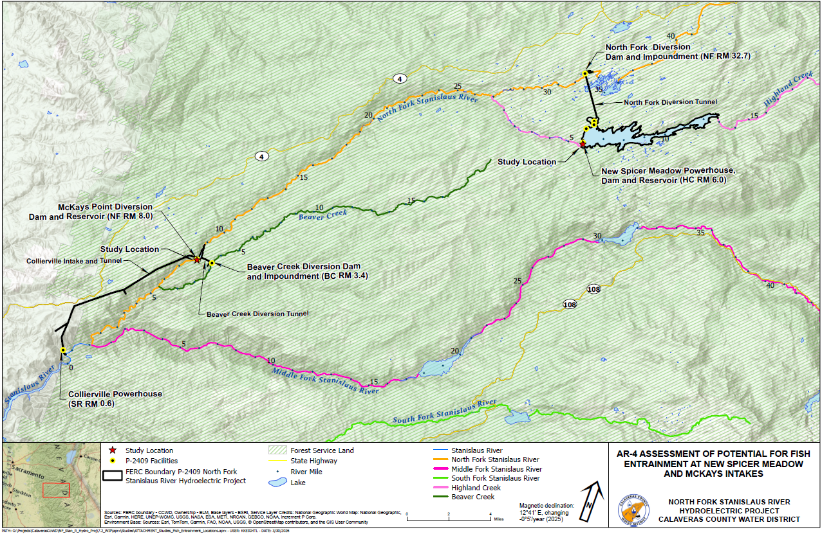
Figure 1. North Fork Stanislaus River Hydroelectric Project AR-4 Study Locations
STUDY METHODS

Methods

A desktop assessment of the potential for fish entrainment at New Spicer Meadow and McKays intakes will be conducted. All information collected during this assessment will be subject to appropriate QA/QC procedures including checking all data for accuracy and completeness.

This assessment will consist of four steps: (1) characterize each intake through which water is released (i.e., New Spicer Meadow and McKays intakes); (2) determine the likelihood that reservoir fish would be near the intakes; (3) determine swim speeds for fish life stages likely to be near the intakes; and (4) compare swim speeds and intake water velocities. These steps are described below:

Step 1 – Characterize Each Intake

CCWD will examine existing design drawings and operations of the intakes to characterize the typical intake depth, dimensions, and flows. Using this information, CCWD will calculate typical approach velocities near and at each intake, and at various distances from the intake. Approach velocities will be calculated by examining the cross sectional area of the tunnel intake structures and the median, 10 percent, and 90 percent exceedance discharges. These values will be compared with the annual inflow/outflow hydrographs to evaluate the temporal risk of entrainment to fish.

Step 2 – Determine Likelihood That Reservoir Fish Would be Near the Intakes

Using the information developed in Step 1, existing information regarding the fish species composition in McKays and New Spicer Meadow reservoirs and information in existing literature regarding the fish species’ life history, CCWD will determine which of the species’ life stages has a reasonable potential to be near the intakes and when. Species will be assessed for potential risk of entrainment under both stratified and non-stratified lake conditions. The seasonality of stratification and its effect on species presence near the intakes will be described from available information.

Step 3 – Determine Swim Speeds for Fish Life Stages Likely to be Near the Intakes

A literature review will be conducted to evaluate the existing understanding of relevant fish swimming capabilities. Using this information, CCWD will determine the swim speeds of fish and their respective life stages that have the potential to be proximal to the tunnel intakes as determined in Step 2. A fish’s ability to avoid entrainment is related to its swimming ability, which is a function of its size.

Step 4 – Compare Swim Speeds and Intake Velocities

CCWD will compare the intake velocities calculated in Step 1 with the swim speeds calculated in Step 3 and assess the potential for fish entrainment at the intakes.

Analysis

CCWD will compare the intake velocities calculated in Step 1 with the swim speeds calculated in Step 3 to determine the risk for fish entrainment.

REPORTING

This Study will generate the tables and plots described above for each step including characterizing each intake, determining relevant fish species, displaying fish swim speeds, and relevant comparison tables.

SCHEDULE

CCWD anticipates the schedule for Study completion as follows:

Conduct Desktop Analysis and Reporting June – December 2027

In addition to the details provided in this study description, study implementation will also follow the "Concepts and Practices Applicable to All Relicensing Studies" developed by CCWD.
In addition to the details provided in this section, reporting will also follow the "Concepts and Practices Applicable to All Relicensing Studies" developed by CCWD.

