STUDY DESCRIPTION TR-1
Botanical Resources Study including Vegetation Mapping and
Protocol Surveys for Special-Status Species and Non-Native Invasive Plants

Draft – April 1, 2026

This Study Description is developed to inform information gaps identified by Calaveras County Water District (CCWD) for the relicensing of its North Fork Stanislaus River Hydroelectric Project (Project).

STUDY AREA

The Study Area includes all areas within the Federal Energy Regulatory Commission (FERC) Project boundary plus a 20-foot buffer around the boundary with the following exceptions: 1) boundaries for underground Project facilities (i.e., tunnels) are not included in the Study Area; 2) at Spicer Meadows Reservoir, the Study Area includes the boundary encompassing the powerhouse, dam, and recreation areas plus a 20 foot buffer (i.e., these are areas where routine ground disturbing activities may occur) and the area within the New Spicer Meadows Reservoir normal maximum water surface elevation (NMWSE) plus a 50 foot buffer area; and 3) at McKays Reservoir, the Study Area includes the boundary encompassing the dam plus a 20 foot buffer and the area within the McKays Dam NMWSE plus a 50 foot buffer area. Figures TR1-1 and TR 1-2 show the Study Area.

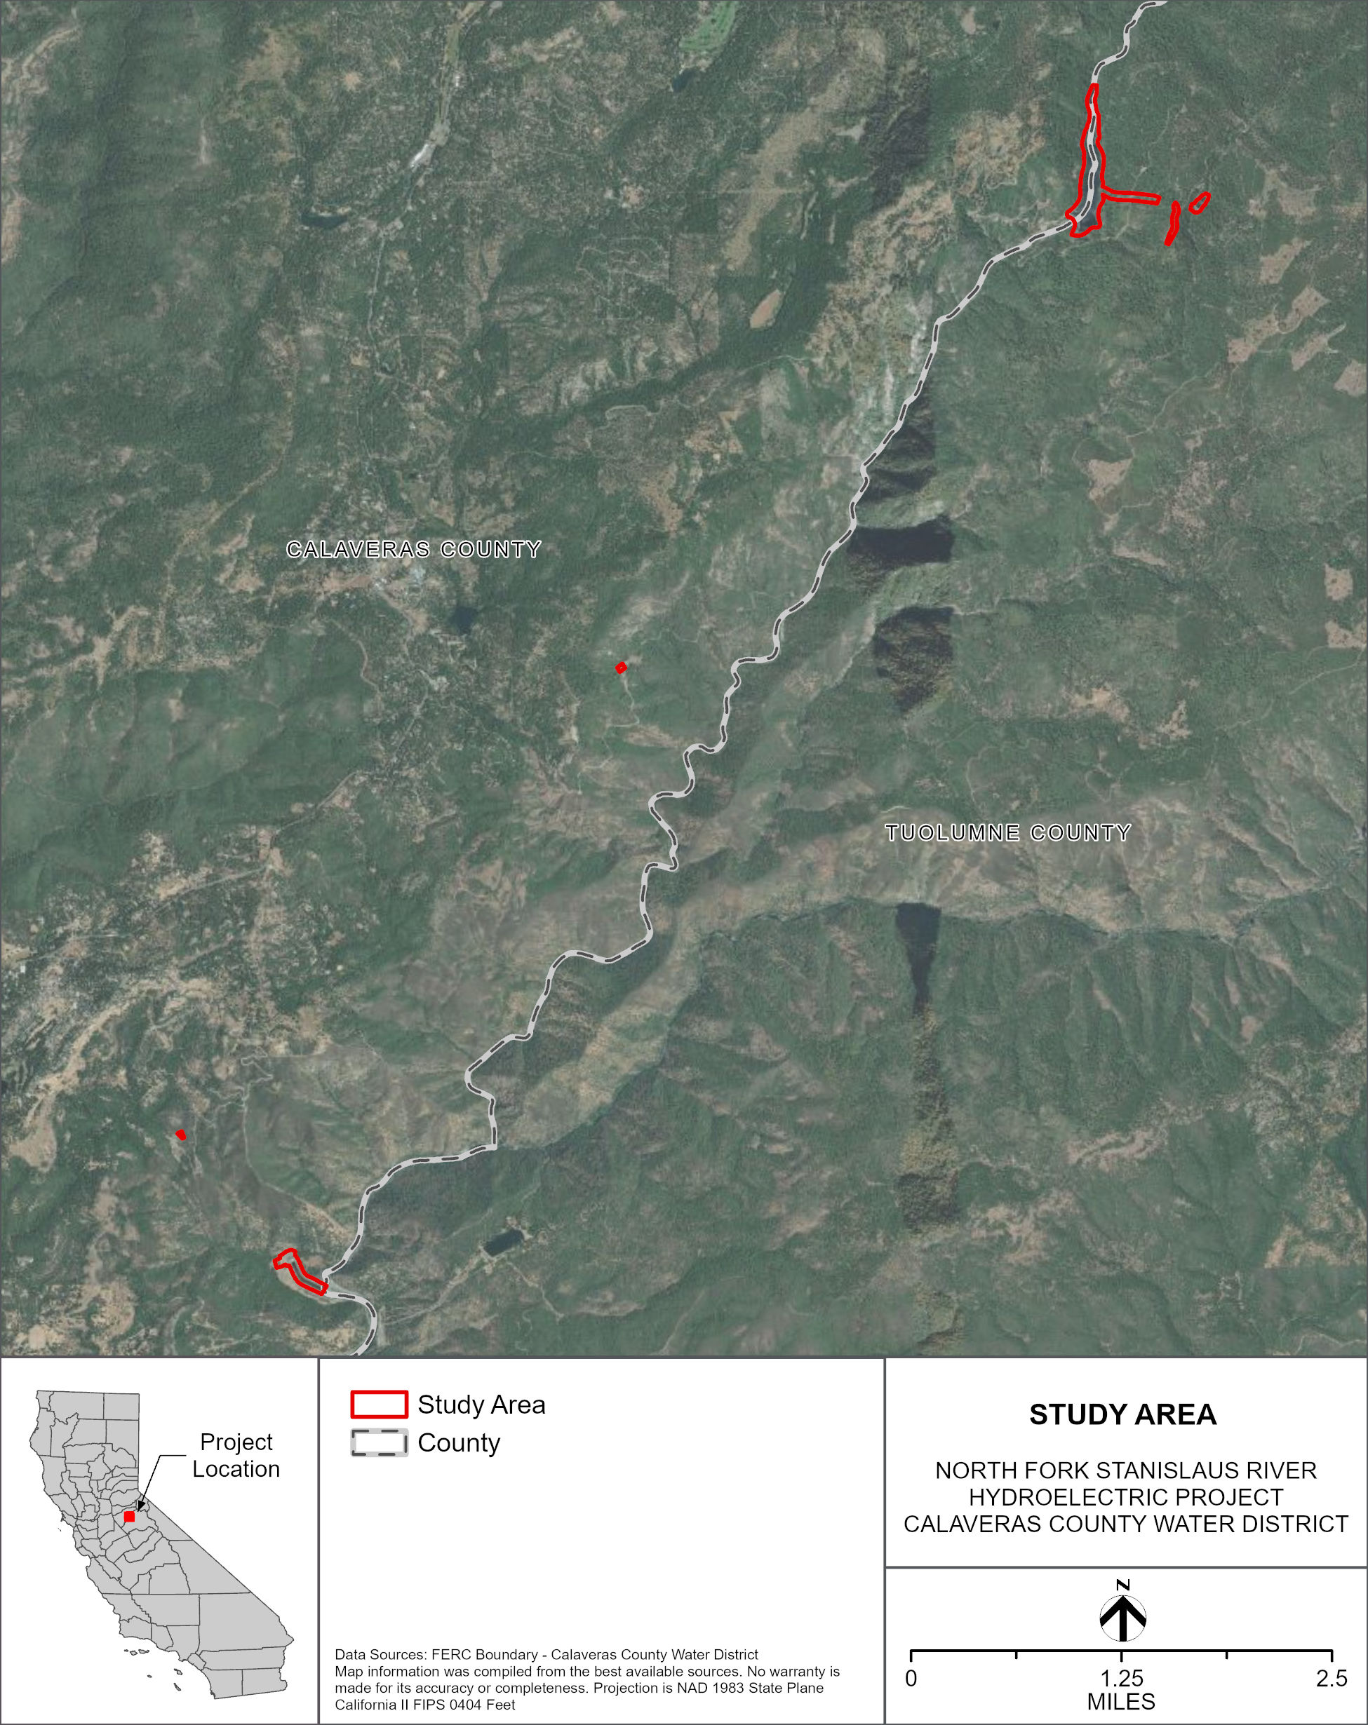
Figure TR 1-1. Study Area (McKays Dam & Collierville Tunnel & Beaver Creek Portion).
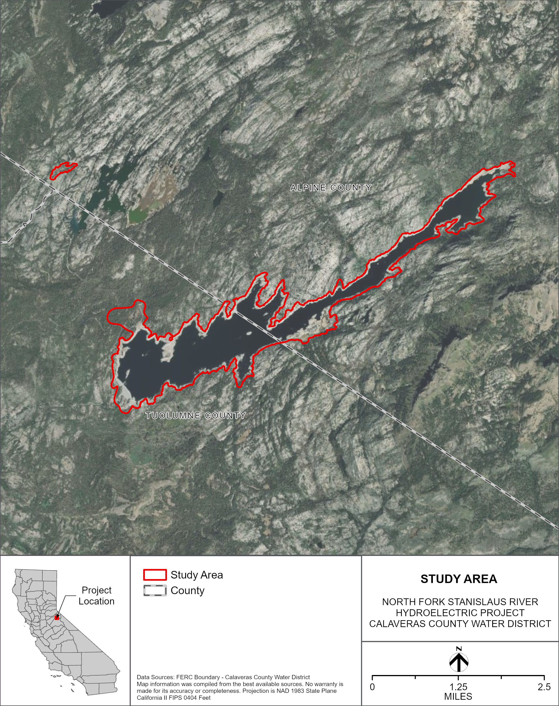
Figure TR 1-2. Study Area (New Spicer Reservoir & North Fork Diversion Dam Portion).
For this Study Description the following definitions apply:

Special-Status Plant
- Is a vascular plant species and, at the time the study is conducted, is;
  - Listed as Threatened or Endangered, or is a candidate or proposed for listing under the federal Endangered Species Act (USFWS 2026) and/or;
  - Listed as Threatened, Endangered, or Rare or is a candidate for listing under the California Endangered Species Act (CDFW 2026a) and/or;
  - Listed as a United States Department of the Interior, Bureau of Land Management (BLM) Sensitive species and occurs on lands administered by BLM (BLM 2026) and/or;
  - Listed by the United States Department of Agriculture, Forest Service (Forest Service) as a Forest Service Sensitive Species or a Stanislaus National Forest (STF) Watch List species and occurs on National Forest System (NFS) lands (STF 2026); and/or
  - Listed by the California Native Plant Society as a Rare Plant with a Rank of 1B (Rare, Threatened, or Endangered Throughout Its Range) or 2B (Rare, Threatened, or Endangered in California, But Common Elsewhere) (CNPS 2026a).

Non-Native Invasive Plant (NNIP)
- Occurs as a discreet occurrence or cluster of occurrences that cumulatively cover less than 1 acre of the Study Area and is;
  - Listed by the California Department of Food and Agriculture (CDFA) with a rating of A (pest of known economic or environmental detriment and is either not known to be established in California or it is present in a limited distribution that allows for the possibility of eradication or successful containment) or B (pest of known economic or environmental detriment and, if present in California, it is of limited distribution) (CDFA 2021) and/or;
  - Listed by the STF on its priority 1 invasive plant list (STF 2026) and is on NFS lands and/or;
  - Listed by the California Invasive Plant Council (Cal-IPC) with a Weed Rating of High (species with severe ecological impacts on physical processes, plant and animal communities, and vegetation structure) (Cal-IPC 2026) and is on lands administered by BLM.

Special status plants and NNIP collectively will hereafter in this study description be referred to as Target Plant Species.

STUDY METHODS

Excluding Data Summary Development (i.e., Reporting), the Study consists of the following four steps: 1) Conduct Desktop Review; 2) Conduct Floristic Field Survey; 3) Prepare Vegetation Map; and 4) Analysis. Each step is described below.

Step 1 – Conduct Desktop Review

CCWD will compile a list of special-status plant species with potential to occur in the Study Area starting with the information from CCWD’s Project Pre-Application Document, or PAD (CCWD 2026) and updated by querying the following:

- United States Department of the Interior, Fish and Wildlife Service’s (USFWS) Information for Planning and Consultation portal (USFWS 2026);
- California Department of Fish and Wildlife’s (CDFW) California Natural Diversity Database (CNDDB) (CDFW 2026b);
- California Native Plant Society’s online Inventory of Rare and Endangered Vascular Plants of California (California Native Plant Society 2026);
- STF’s updated list of Threatened, Endangered, Sensitive, and Watch List Plants (Forest Service 2026); and
- BLM’s updated list of Sensitive Species (BLM 2026).

Should a list of culturally significant plants for relicensing be provided by Native American Tribe(s) (developed under Study CR-2), information on the culturally significant plants will be compiled and used to inform field studies and reporting needs.

With respect to NNIP, CCWD will compile a list of potential NNIP species using CCWD’s PAD (CCWD 2026) as well as the most current CDFA list of noxious weeds (CDFA 2021), STF’s Invasive Plant List (Forest Service 2026), and the list of Cal-IPC ranked High species known to occur in the upper Stanislaus River watershed (Cal-IPC 2026).

Step 2 – Conduct Floristic Field Survey

CCWD’s surveyors will generally conduct Target Species and vegetation community mapping as outlined in Protocols for Surveying and Evaluating Impacts to Special Status Native Plant Populations and Sensitive Natural Communities (CDFW 2018). The surveys will be floristic in nature. Scientific and common names for those species that are considered special status will conform to the nomenclature found in CDFW’s Special Vascular Plants, Bryophytes, and Lichens List (CDFW 2026b) while all other species’ scientific names will conform to the nomenclature found on the Jepson eFlora (Jepson Flora Project 2026). Other species’ common names will conform to the nomenclature found on the Jepson eFlora.

In addition, field survey methods will generally conform to the BLM Special-Status Plant Protocol for an Intuitive Controlled Survey (BLM 2009) as well as the Forest Service Handbook 2609.26, Chapter 10, Sensitive Plant Program Management (Forest Service 2019), and will include mapping NNIP occurrences.

The Study Area will be surveyed twice for Target Species except that the Study Area above an elevation of 6,000 feet will be surveyed for Target Species once because of the narrower phenology window of higher elevation species.

Special-status Plants

If special-status plant occurrences are located in the Study Area, the following information will be collected:

- Digital photographs (both large and small scale) showing the species and its habitat (one set only per taxa);
- If an occurrence is estimated to cover an area greater than 0.05 acre, surveyors will delineate the occurrence boundary using a handheld GPS, collecting either polygon data or sufficient point data such that a realistic polygon can be constructed from the point data using a geographic information system (GIS);
- For occurrences less than 0.05 acre in size, the location of the approximate center of the occurrence will be taken as point data using a handheld GPS unit; and
- Ecological information sufficient to fill out a CNDDB form such as population size, co-occurring species, soil information, and other data.

Non-native Invasive Plants

If NNIP occurrences are found in the Study Area, surveyors will collect the following data to the edge of the occurrence or to the edge of the Study Area if the occurrence goes beyond it:

- Digital photographs depicting the species and its habitat (one set only per species);
- If an occurrence is estimated to cover an area greater than 0.05 acre, surveyors will delineate the occurrence boundary using a handheld GPS unit, collecting either polygon data or sufficient point data such that a realistic polygon can be constructed from the point data using GIS;
- For occurrences less than 0.05 acre in size, the location of the approximate center of the occurrence will be taken as point data using a handheld GPS unit;
- Estimated population total; and
- Any noted disturbances in or near the occurrence.
Step 3 – Prepare Vegetation Map

Vegetation types will be mapped on a mapbook with aerial photographs covering the Study Area. Where vegetation overlaps with another type of mapping unit, such as a tree canopy over water or roads, the area will be mapped according to the uppermost layer of vegetation. A minimum mapping unit of 0.1 acre will be used when differentiating vegetation types. Some vegetation types may be mapped below the level of 0.1 acre, such as vegetation types typically associated with wetland features, at the discretion of the surveyors. Vegetation mapping will occur concurrently with surveys for Target Species. Vegetation mapping will not require surveyors to physically access each mapped polygon but be mapped from appropriate vantage points to view the Study Area.

For each vegetation type observed in the field, species composition and percent cover will be recorded on vegetation mapping forms. Nomenclature of vegetation types will follow that of the Manual of California Vegetation Online (CNPS 2026b) to allow for importing into CDFW’s Vegetation Classification and Mapping Program (CDFW 2025) as a requirement to the Protocols for Surveying and Evaluating Impacts to Special Status Native Plant Populations and Sensitive Natural Communities (CDFW 2018). If a vegetation type is recorded that does not conform to a described vegetation type, a new name will be created conforming to the general format of the Manual of California Vegetation Online (CNPS 2026b). These vegetation layers will be used to inform components of Study TR-3, as it can be imported into the California Wildlife Habitat Relationships (CWHR) model.

Step 4 - Analysis

Analysis of Target Species data will consist of reviewing field forms and comparing them and GIS datasets to verify that all required data are recorded and there are no data gaps. Plant species unable to be confidently identified in the field will have pictures or samples reviewed and identified. If necessary, CCWD will use the herbarium at the University of California Davis to compare samples and pictures with expertly identified voucher samples.

Vegetation data will be reviewed with the Manual of California Vegetation Online (CNPS 2026b) to assign labels to each vegetation type mapped in the field. Field maps will be digitized to complete a final vegetation layer for the Project. All Project photographs taken in the field and intended for inclusion in future reporting will be catalogued and labeled for future use.

REPORTING

This Study will generate GIS maps of special-status plant and NNIP occurrences as well as vegetation map of the Project. GIS shapefiles will also be made of each of the three study results. CNDDB forms for special-status plants will also be completed.
SCHEDULE

CCWD anticipates the schedule for Study completion as follows:

Conduct Desktop Review January – March 2027
Conduct Floristic Field Survey April – September 2027
Prepare Vegetation Map April – September 2027
Analysis August – September 2027
Data Summary Development September – November 2027

REFERENCES

Bureau of Land Management (BLM). 2026. Information on BLM Sensitive species for California. Transmitted by BLM on January 15, 2026.
Calaveras County Water District (CCWD). 2026. North Fork Stanislaus River Hydroelectric Project FERC Project No. 2409 Pre-Application Document (PAD) Volume 1. Prepared by HDR.
California Department of Fish and Wildlife (CDFW). 2018. Protocols for Surveying and Evaluating Impacts to Special Status Native Plant Populations and Sensitive Natural Communities. CDFW, Natural Heritage Division, Sacramento, CA. Available online at: https://wildlife.ca.gov/Conservation/Survey-Protocols#377281280-plants.
_____. 2025. “Vegetation Classification and Mapping Program (VegCAMP).” Natural Heritage Division, Sacramento. Available online at: https://wildlife.ca.gov/Data/VegCAMP.
_____. 2026a. Special Animals List. Available online at: https://wildlife.ca.gov/Conservation/SSC.
_____. 2026b. “California Natural Diversity Database Maps and Data.” California Natural Diversity Database: Rarefind 5, records of occurrence. Natural Heritage Division, Sacramento. Available online at: https://www.wildlife.ca.gov/Data/CNDDB/Maps-and-Data.
_____. 2026b. “Special Vascular Plants, Bryophytes, and Lichens List.” Natural Heritage Division, Sacramento, California. Available online at: https://www.wildlife.ca.gov/Data/CNDDB/Plants-and-Animals.
California Department of Food and Agriculture (CDFA). 2021. “CDFA Weed Pest Ratings and CCR 4500 Noxious Weeds.” Last updated June 22, 2021. Available online at: https://www.cdfa.ca.gov/plant/ipc/encycloweedia/pdf/CaliforniaNoxiousWeeds.pdf.
California Invasive Plant Council (Cal-IPC). 2026. “California Invasive Plant Inventory Database.” Berkeley. Available online at: http://cal-ipc.org/ip/inventory/index.php/.
California Native Plant Society. 2026a. “CNPS Rare Plant Inventory.” Inventory of rare and endangered vascular plants of California. (Online Edition, v9.5.1). Sacramento. Available online at: http://www.rareplants.cnps.org/.
_______. 2026b. A Manual of California Vegetation Online. Available online at: https://vegetation.cnps.org/.
Jepson Flora Project. 2026. “Jepson eFlora” (Revision 14). University of California, Berkeley. Last updated March 12, 2026. Available online at: http://ucjeps.berkeley.edu/IJM.html.
Stanislaus National Forest (STF). 2026. Information on Forest Service Sensitive, Watch List, and Invasive species for the Stanislaus National Forest. Transmitted by SNF on January 12, 2026.
United States Department of Agriculture, Forest Service. 2019. Forest Service Handbook 2609.26, Chapter 10, Sensitive Plant Program Management. Pacific Southwest Region (R5). Available online at: https://www.fs.usda.gov/im/directives/field/r5/fsh/2609.26/R5-2609-26-Contents-2020-1%203a.pdf.
____, Stanislaus National Forest (STF). 2026. Information on Forest Service Sensitive, Watch List, and Invasive species for the Stanislaus National Forest. Transmitted by Stanislaus National Forest on January 12, 2026.
United States Department of the Interior, Bureau of Land Management (BLM). 2009. Survey Protocols Required for NEPA/ESA Compliance for BLM Special Status Plant Species. Bureau of Land Management California State Office. Geographic Services.
U.S. Fish and Wildlife Service (USFWS). 2026. Information for Planning and Consultation. Environmental Conservation Online System. Available online at: https://ecos.fws.gov/ecp/. United States Fish and Wildlife Service. Washington D.C.

In addition to the details provided in this study description, study implementation will also follow the "Concepts and Practices Applicable to All Relicensing Studies" developed by CCWD.
In addition to the details provided in this section, reporting will also follow the "Concepts and Practices Applicable to All Relicensing Studies" developed by CCWD.
The timing for the field surveys is based on the range of elevation range of the study area and the phenology of target species within the study area

