STUDY DESCRIPTION TR-2
Protocol-level Surveys for Bald Eagle

Draft – April 1, 2026

This Study Description is developed to inform information gaps identified by Calaveras County Water District (CCWD) for the relicensing of its North Fork Stanislaus River Hydroelectric Project (Project).

STUDY AREA

The Study Area includes the area within the normal maximum water surface elevation (NMWSE) of New Spicer Meadow Reservoir plus the visible area of a 1.0-mile around the reservoir’s edge. Figure 1 shows Study Area.

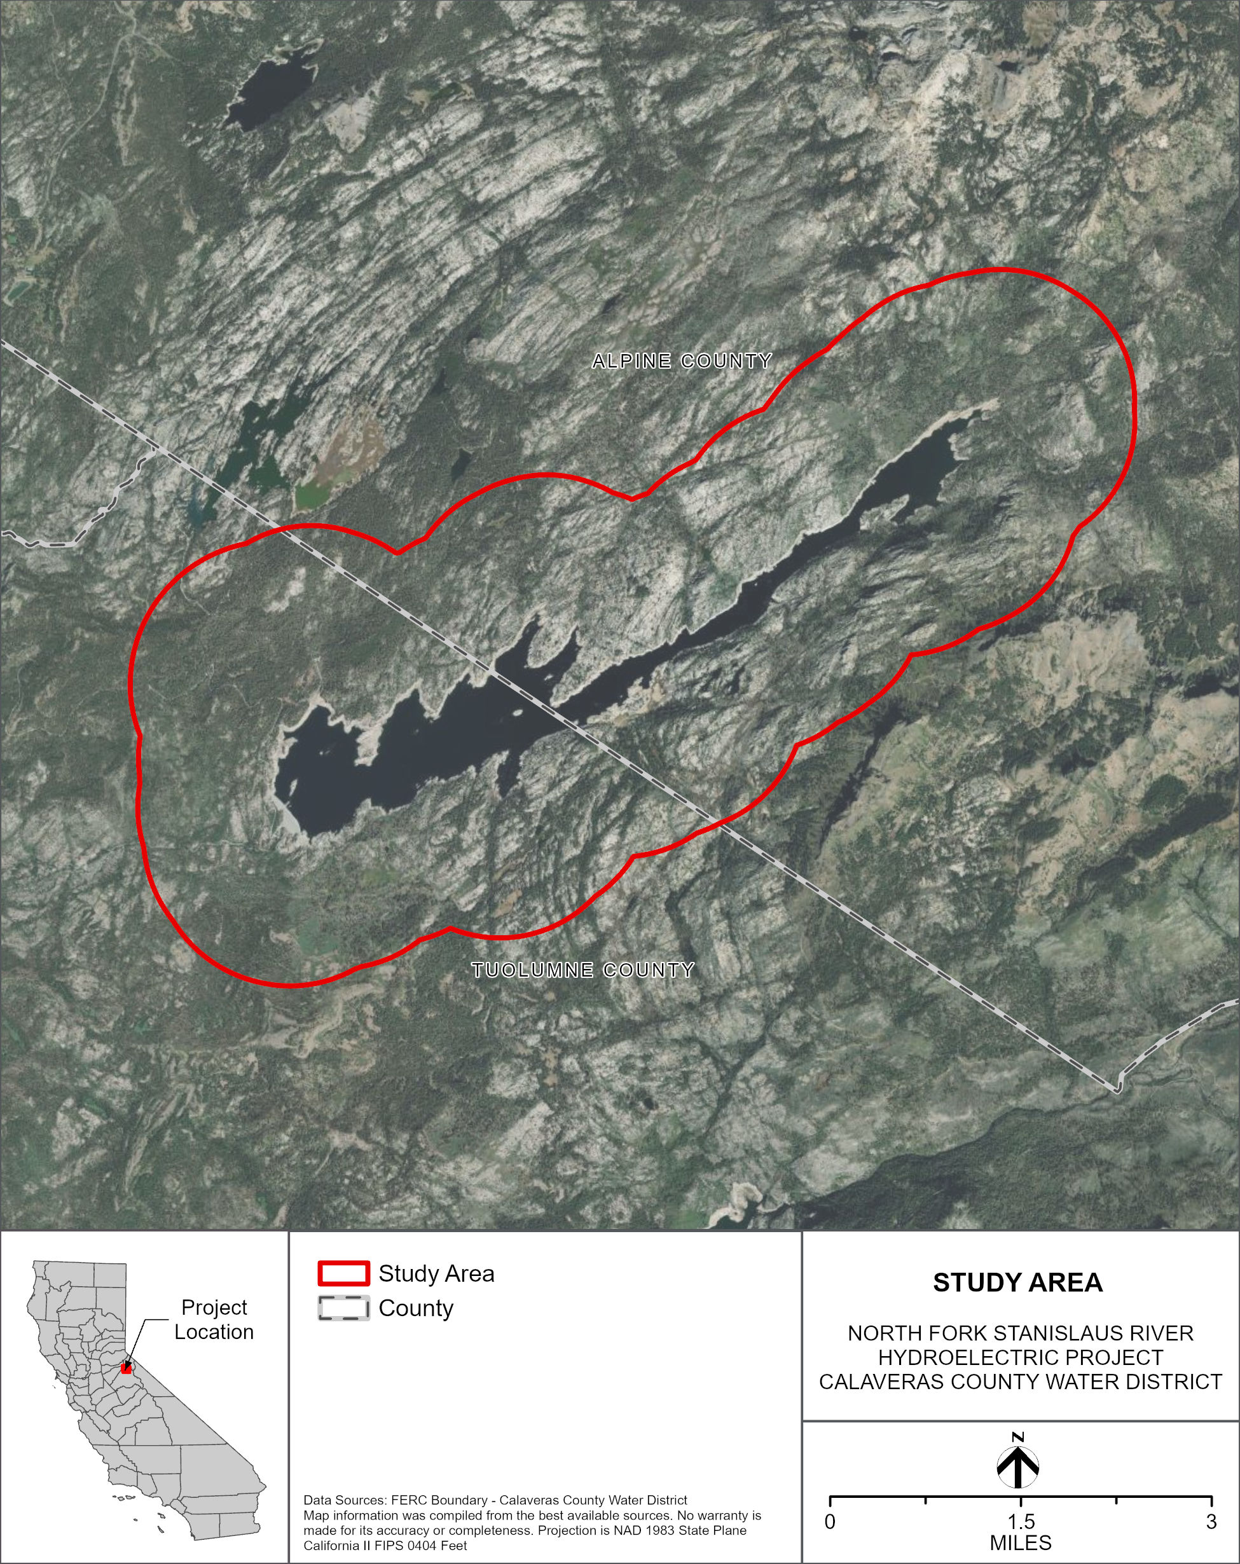
Figure TR 2-1. Study Area for bald eagle nest surveys.

STUDY METHODS

Excluding Data Summary Development (i.e., Reporting), the Study consists of the following two steps: 1) Identify and Map Known Bald Eagle (Haliaeetus leucocephalus) Winter Roosts and Nest Sites Occurrences; and 2) Conduct Field Surveys for Bald Eagles. Both steps are described below.

Step 1 – Identify and Map Known Bald Eagle Winter Roosts and Nest Sites

CCWD will identify and map any known occurrences of bald eagles, including nests and winter roosts in the Study Area. For informational purposes, known nests and roosts of other special-status raptors in the Study Area will be noted. The map will be based on: California Department of Fish and Wildlife’s California Natural Diversity Data Base (CNDDB) existing data (CDFW 2026); confirmed eBird (Cornell Lab of Ornithology 2026); verified iNaturalist (iNaturalist 2026) sitings; information provided by the Stanislaus National Forest (STF); and discussions with Project Operations Staff.

Step 2 – Conduct Field Surveys for Bald Eagle

Bald Eagle Surveys

CCWD will conduct nesting surveys according to the Protocol for Evaluating Bald Eagle Habitat and Populations in California (Jackman and Jenkins 2004). More in-depth survey methodology and descriptions can be found in the associated Field Methods section of this document.

Bald Eagle surveys will be conducted from a boat or by foot, depending on weather conditions and accessibility. If by boat, it is assumed that the surveyor will be able to visually observe an area of approximately 0.25-mile from the water’s edge of New Spicer Meadow Reservoir. Surveying should concentrate on areas closest to the water but search up to 1.0-mile from the shoreline within suitable habitat (Jackman and Jenkins 2004).

CCWD will conduct nesting surveys according to the Bald Eagle Breeding Survey Instructions (CDFG 1999) and Protocol for Evaluating Bald Eagle Habitat and Populations in California (Jackman and Jenkins 2004). Nesting territories will be checked at least three times during the nesting season (March through July). Survey methods include:

- Determine Occupancy of Territories and Early Incubation – Territories will be checked in early March, as weather conditions and access allows. Data collected at each site will consist of: 1) presence of adults; 2) courtship behavior; 3) evidence of nest repair or construction; 4) incubation; 5) observation of old nests: and 6) identification of new nests. Surveys will be performed by boat, GPS coordinates will be recorded, and photographs taken for all nests observed.
- Confirm Occupancy of Territories and Presence of Eggs/Nestlings – Surveys will be conducted in late April or early May to determine whether breeding pair identified during the March survey is still tending to the nest (e.g., incubating eggs or rearing nestlings). The number of eggs/nestlings, bird behavior, and any other relevant observations will be recorded. These surveys will be conducted in the same manner as the initial surveys.
- Determine Nest Success – Surveys will be conducted in mid-June to determine how many nestlings are approaching fledgling age. These surveys will be conducted in the same manner as the other nesting surveys. The CDFW California Bald Eagle Nesting Territory Survey Form (CDFG 1999) will be utilized during all nesting surveys.

REPORTING

The study will generate maps and GIS data for previously known and newly mapped bald eagle nests and observations. Completed CNDDB forms and California Bald Eagle Nesting Territory Survey Forms will also be produced.

SCHEDULE

CCWD anticipates the schedule for Study completion as follows:

Identify and Map Known Occurrences November 2026 – February 2027
Conduct Bald Eagle Surveys (February) March – August 2027
Data Summary Development September – November 2027

REFERENCES

California Department of Fish and Game (CDFG). 1999. Bald Eagle Breeding Survey Instructions. November 1999. Sacramento, CA. Available online at: https://nrm.dfg.ca.gov/documents/docviewer.aspx.
California Department of Fish and Wildlife (CDFW). 2026. California Natural Diversity Database (CNDDB). Available online at: https://wildlife.ca.gov/Data/CNDDB.
Cornell Lab of Ornithology. 2026. eBird. Species observed, Spicer Meadow Reservoir (TUL Co.). Available online at: https://ebird.org/hotspot/L1230794/bird-list.
iNaturalist. 2026. Observations. Available online at: https://inaturalist.org/observations.
Jackman, R.E. and J.M. Jenkins. 2004. Protocol for Evaluation Bald Eagle Habitat and Populations in California. Prepared for U.S. Fish and Wildlife Service. Sacramento, CA. Available online at: https://nrm.dfg.ca.gov/documents/docviewer.aspx.

In addition to the details provided in this study description, study implementation will also follow the "Concepts and Practices Applicable to All Relicensing Studies" developed by CCWD.
Other special-status raptor species that may occur in or near the Project include American goshawk (Accipiter atricapillus), golden eagle (Aquila chrysaetos), short-eared owl (Asio flammeus), long-eared owl (Asio otus), Northern harrier (Circus hudsonius), white-tailed kite (Elanus leucurus), and great gray owl (Strix nebulosa).
Spicer Meadow Reservoir is inaccessible during winter months, so Study TR-2 does not include winter surveys.
Surveys may start in February if weather and access allow.
In addition to the details provided in this section, reporting will also follow the "Concepts and Practices Applicable to All Relicensing Studies" developed by CCWD.

