STUDY DESCRIPTION AR-5
Instream Flows
Draft – 7/15/26

This Study Description is developed to address information gaps identified by Calaveras County Water District (CCWD) for the relicensing of its North Fork Stanislaus River Hydroelectric Project (Project).

STUDY AREA

The Study Area includes four stream reaches extending from directly below Project reservoirs downstream to the first major tributary. These locations were selected because they have the highest potential for flows to be influenced by Project operations. The four study reaches are listed below from upstream to downstream and shown in Figure 1:
- North Fork Stanislaus River (NFSR) from the North Fork Diversion Dam to the confluence with Highland Creek;
- Highland Creek from New Spicer Meadow Dam to the confluence with the NFSR;
- NFSR from McKays Point Diversion Dam to the confluence with Beaver Creek; and
- Beaver Creek from Beaver Creek Diversion Dam to the confluence with the NFSR.

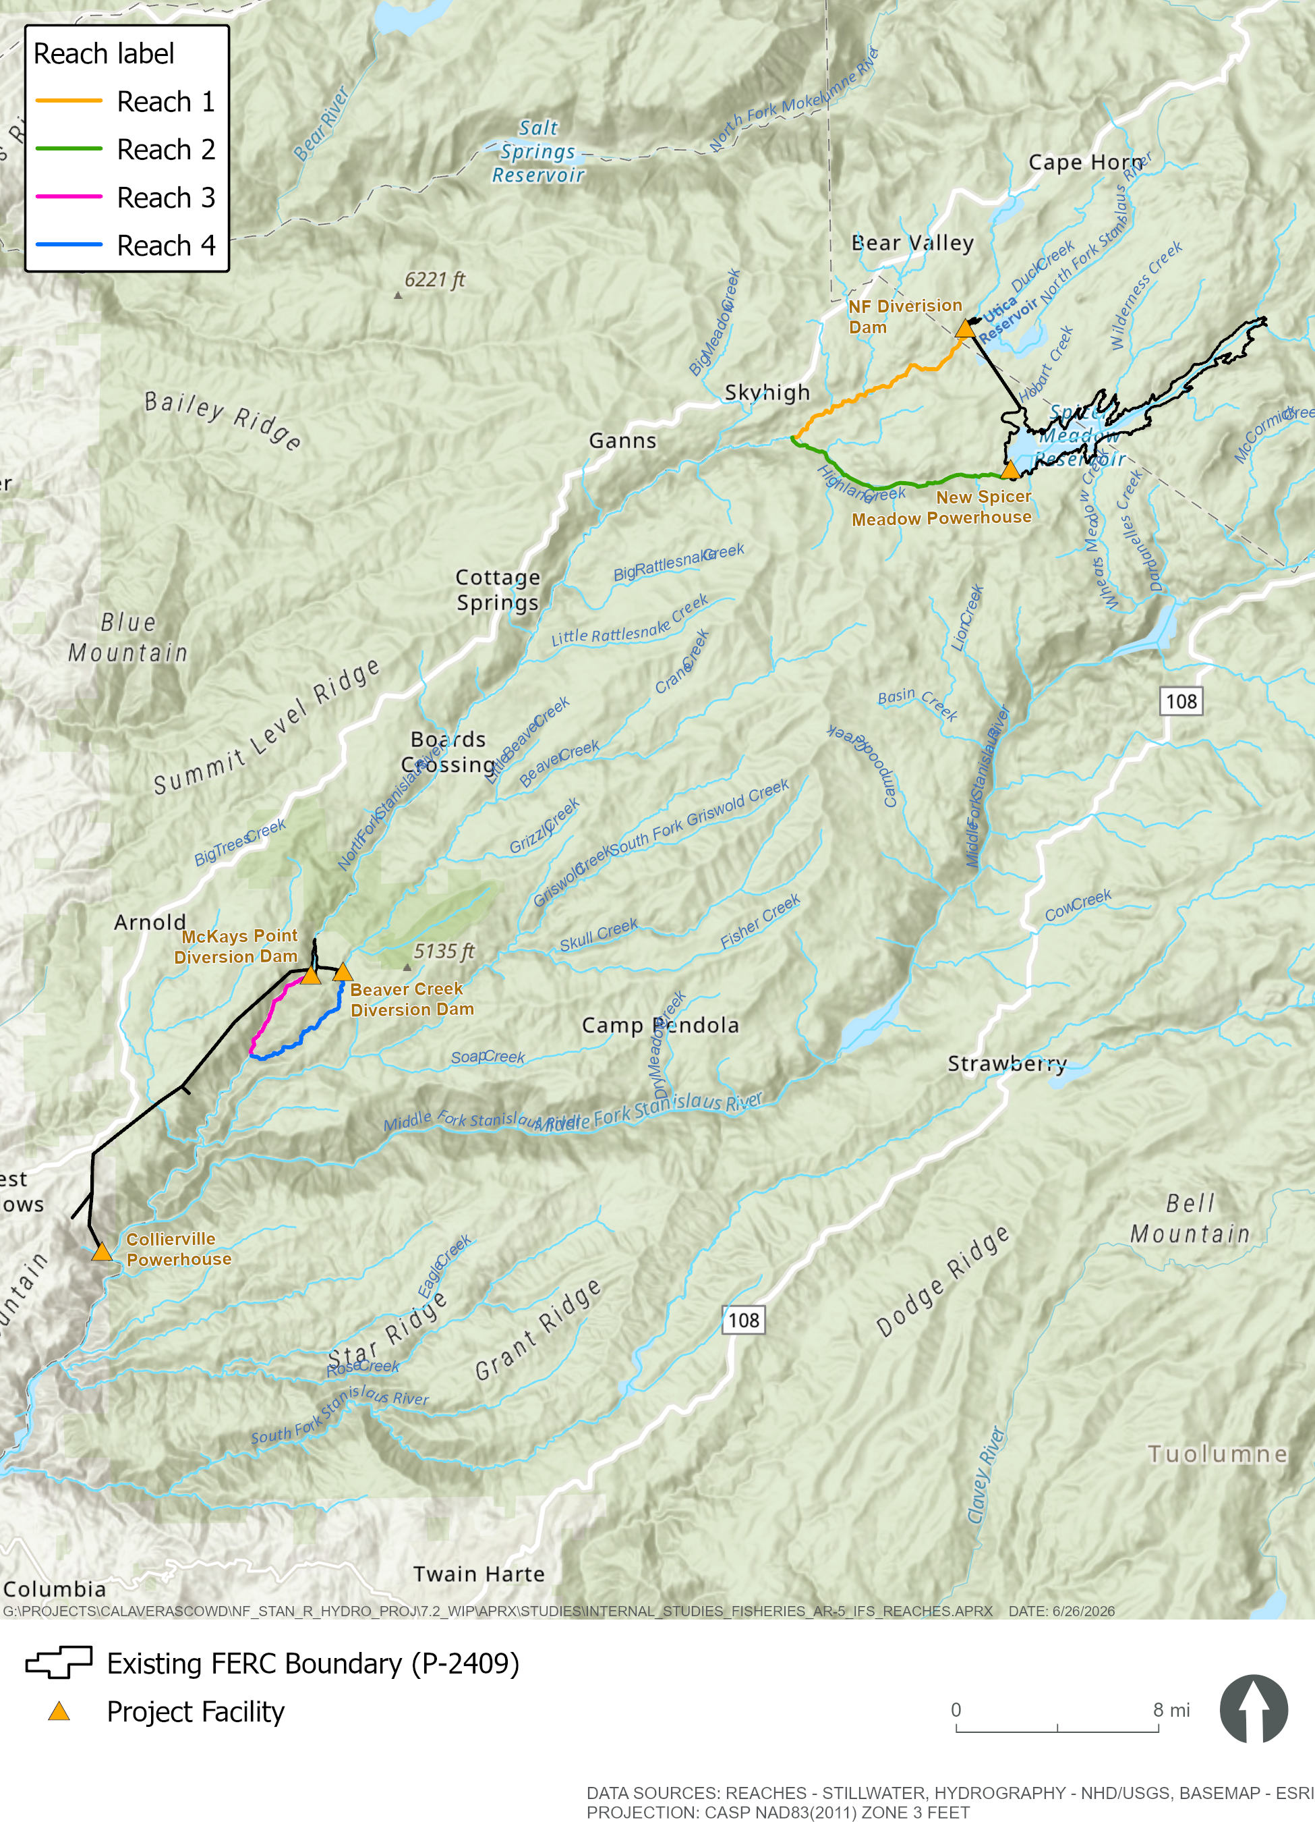
Figure 1. Instream flow study reaches.

STUDY METHODS

Excluding Data Summary Development (i.e., Reporting), this Study consists of the following seven steps, each of which is described below: 1) Map Stream Habitat Types; 2) Select Study Sites; 3) Select Transects; 4) Collect Field Data; 5) Perform Hydraulic Modeling; and 6) Perform Habitat Modeling. CCWD will use the United States Department of the Interior, Fish and Wildlife Service’s (USFWS) Instream Flow Incremental Methodology (IFIM) to evaluate the relationship between streamflow and habitat for rainbow trout fry, juveniles, adult, and spawning life stages. IFIM is a structured habitat evaluation process initially developed by the USFWS’s Instream Flow Group in the late 1970s (Bovee and Milhous 1978; Bovee et al. 1998) to allow evaluation of alternative flow regimes for water development projects. Physical Habitat Simulation (PHABSIM) is a component of IFIM that links hydraulic models with species’ and life-stage-specific habitat suitability criteria (HSC) to compute an index of habitat suitability over a range of flows. PHABSIM modeling will use HSC developed for the Middle Fork and South Fork Stanislaus River, including site-specific curves for juvenile and adult rainbow trout, and literature-based curves developed by the HSC workgroup for rainbow trout fry and spawning life stages (TRPA 2002).

Improvements have been made to the IFIM process and results interpretation (Bovee 1982), approaches to defining study reaches (Morhardt et al. 1984), transect selection (Payne 1992), data collection, computer modeling, and analysis (Milhous et al. 1984, 1989; Bovee and Zuboy 1988; Milhous and Schneider 1985). One such improvement is the System for Environmental Flow Analysis (SEFA) model for simulating physical habitat. This model is an adaptation of the PHABSIM software that was originally developed and maintained by the USFWS’s Instream Flow and Aquatic Systems Group in Fort Collins, Colorado (Milhous 1973, Bovee 1982, Milhous et al. 1984). The SEFA software implements the equivalent algorithms of PHABSIM models, but features expanded input, output, graphic, and calibration capabilities (Payne and Jowett 2013). CCWD will use a mesohabitat and transect-based approach (commonly referred to as the one-dimensional [1-D] method) in each study reach when applying the SEFA model under the IFIM.

Step 1 - Map Stream Habitat Types

Habitat typing involves delineating aquatic habitat into individual habitat units based on geomorphic characteristics and assigning distinct habitat types to each unit. Study reaches may be further divided into subreaches to help characterize changes in habitat composition if major differences in channel slope, confinement, or stream flow are identified during the habitat mapping effort. Biologists will conduct habitat typing within each study reach using a combination of aerial imagery and pedestrian surveys. CCWD will obtain current orthophotography of the Study Area using a fixed winged aircraft. Individual habitat units will be classified using a three-tiered habitat mapping classification system (Hawkins et al. 1993) and characterized to Level III channel geomorphic unit (“mesohabitats”), as shown in Figure 2 and described in Table 1.
Channel Geomorphic Unit
Slow Water
Non-turbulent
Turbulent
Fast Water
Dammed Pool
Scour Pool
Fall
Cascade
Chute
Rapid
Low Gradient Riffle
High Gradient Riffle
Glide
Run
Step-run
Pocket Water
Sheet
Level I Level II Level III
Convergence
Mid-channel
Lateral
Trench
Plunge
Debris
Beaver
Landslide
Figure 2. Three-tiered habitat classification system adapted from Hawkins et al. (1993) and McCain et al. (1990)

Habitat units will be delineated where the unit length is greater than 1 to 2 times the active channel width (Flosi et al. 2010) or when the unit is otherwise distinctive. Habitat typing will be contiguous with each habitat unit abutted to the next unit. Each distinct habitat unit will be numbered consecutively beginning at the downstream end of the study reach and moving in an upstream direction. The length of each habitat unit will be measured and the relative proportion of habitat types within each study reach will be calculated. Off-channel habitat units such as backwaters or abandoned channels will be noted but excluded from further analysis.

Data from the habitat typing will be used to: 1) characterize habitats in the study reaches, 2) establish appropriate and representative study sites, and 3) extrapolate results from the SEFA model analysis throughout the reach to develop flow-habitat relationships that represent the entire study reach.

Table 1. Habitat types to be used for the instream flow study (adapted from McCain et al. 1990, Armantrout 1998, Payne 1992, McMahon et al. 1996, and Hawkins et al. 1993)
I. Fast Water: | Riffles, Rapid, Shallow Stream Sections with Steep Water Surface Gradient
- Turbulent: | Channel units having swift current, high channel roughness (large substrate), steep gradient, and non-laminar flow and characterized by surface turbulence
- Fall: | Steep vertical drop in water surface elevation. Generally cannot be modeled.
- Cascade: | Series of alternating small falls and shallow pools; substrate usually bedrock and boulders. Gradient high (more than 4%). Generally cannot be modeled.
- Chute: | Narrow, confined channel with rapid, relatively unobstructed flow and bedrock substrate.
- Rapid: | Deeper stream section with considerable surface agitation and swift current; large boulder and standing waves often present. Generally cannot be modeled.
- Low gradient riffle | Shallow with swift flowing, turbulent water. Partially exposed, cobble dominant substrate. Gradient moderate (less than 4%).
- High gradient riffle | Moderately deep with swift flowing, turbulent water. Partially exposed, boulder dominant substrate. Gradient steep (greater than 4%). Generally cannot be modeled.
- Non-turbulent: | Channel units having low channel roughness, moderate gradient, laminar flow, and lack of surface turbulence
- Glide | Shallow water flowing over a variety of different substrates
- Run | Deep water flowing over a variety of different substrates
- Step Run | A sequence of runs separated by short riffle steps. Substrates typically cobble and boulder dominant.
- Pocket water: | Swift flowing water with large boulder or bedrock obstructions creating eddies, small backwater, or scour holes. Gradient low to moderate.
- Sheet: | Shallow water flowing over smooth bedrock.
II. Slow Water: | Pools; slow, deep stream sections with nearly flat-water surface gradient.
- Scour Pool: | Formed by scouring action of current.
- Convergence | Formed where two stream channels meet.
- Mid-channel: | Formed by channel constriction or downstream hydraulic control.
- Lateral: | Formed where flow is deflected by a partial channel obstruction (streambank, rootwad, log, or boulder).
- Trench: | Formed by scouring of bedrock.
- Plunge: | Formed by water dropping vertically over channel obstruction.
- Dammed Pool: | Water impounded by channel blockage.
- Debris: | Formed by rootwads and logs.
- Beaver: | Formed by beaver dam.
- Landslide: | Formed by large boulders.

Step 2 - Select Study Sites

Study sites will include a group of Level III Category mesohabitat units selected to use in the SEFA model. Selection of study sites within the study reaches will be accomplished using a combination of random selection and professional judgment following the procedure outlined in CDFW (2015). The procedure is based on the number and overall proportion of habitat types and provides assurance that all major habitat types will be sampled in relative proportion to the overall reach. Prior to study site selection, portions of a reach will be removed from consideration as a study site for one or more of the following:
- Safety risk;
- Accessibility difficult;
- high gradient riffles and cascade habitats because these habitats are usually not compatible with existing hydraulic models;
- other “non-modelable” habitats containing characteristics such as transverse flow, multiple water surfaces across the channel, and units immediately upstream of cascades or rapids; and
- mesohabitat types that account for less than 10 percent of the total reach.

Within each reach, the mesohabitat type that have not been removed from consideration with the lowest percentage of abundance by length, but greater than 10 percent of the total, will be selected to serve as the basis for selection of a random, starting habitat unit. All habitat units within this habitat type category will be sequentially numbered from downstream to upstream and one habitat unit will be randomly selected using a random number generator. The randomly selected habitat unit will then be located in the field and flagged for inclusion in the study site. From the starting habitat unit selected, at least one example of each remaining mesohabitat type will then be located in the immediate vicinity of the starting habitat unit (the closest unit upstream or downstream). Using this approach, a “cluster” of habitat units will be selected which reduces travel time between transects. The same procedure will be followed until one to three survey units of each mesohabitat type are selected in each study reach. Additional habitat units may be selected non-randomly to represent unique, rare, or otherwise important habitat units (e.g., spawning).

Resource agencies will be provided advance notice and invited into the field to observe study site selection.

Step 3 - Select Transects

Transects will be placed within the habitat units of the selected study sites. Transects within a habitat unit will be specifically placed based on CCWD’s consultant’s professional judgment to avoid random placement in unusual channels or hydraulic anomalies that may interfere with model accuracy. A sufficient number of transects will be established within each reach to adequately model the proportional frequency of habitat types and provide a robust estimate of available habitat in the reach (Payne et al. 2004). Relatively hydraulically homogeneous habitat units require one to three transects per replicate. Approximately 12 to 20 transects will be located within each study reach. Resource agencies will be provided advance notice and invited into the field to observe transect selection

Step 4 - Collect Field Data

Data collection and recording will be conducted consistent with standardized procedures and guidelines from PHABSIM field technique manuals published by the Instream Flow Group (Trihey and Wegner 1981; Milhous et al. 1984). Water surface elevation and flow measurements will be collected at each site during three separate flow events—low flow, medium flow, and high flow. Depth and velocity will be measured for calibration purposes at each transect during a single high- or medium-flow event (the “one-flow” method). Calibration flows will be selected to allow the models to simulate a range of flows representative of existing and potential management conditions. The target low calibration flow will be approximately the current minimum instream flow (i.e., 16.5 cfs). The target high calibration flow will allow modeled habitat conditions up to approximately 250 cfs. Discharge measurements will follow CDFW (2020) guidelines.

Step 5 - Perform Hydraulic Modeling
Stage-discharge relationships for all transects will be developed from measured discharge and water surface elevation using a Stage-of-Zero-Flow (SZF) log/log regression formula using the SEFA default method of fitting the rating curve through the survey flow. The SZF method requires a minimum of three sets of stage-discharge measurements and an estimate of the SZF flow for each transect. A single set of velocities (commonly referred to as the one-flow method) will be used for velocity simulations. Under this option, velocities are simulated up and down from the measured flow based on the channel’s capacity to convey water (a function of hydraulic radius) and a calculated roughness coefficient (Manning’s N) for each velocity measurement point.

Step 6 - Perform Habitat Modeling

Habitat will be modeled using the suite of submodels produced by the SEFA model and HSC developed by TRPA (2002) for the Middle and South Fork Stanislaus River PHABSIM modeling, which incorporated direct observation and habitat use data from the North Fork Stanislaus River. The HSC employed in these analyses are presented in Tabes 2 and 3.
Table 2. Habitat Suitability Criteria curve points developed by TRPA (2002) proposed for use in Study AR-5.
Life stage | Velocity | Suitability | Depth | Suitability | Substrate¹ | Suitability
Fry | 0.00 | 1.00 | 0.00 | 0.00 | -- | --
Fry | 0.50 | 1.00 | 0.40 | 1.00 | -- | --
Fry | 1.00 | 0.20 | 1.75 | 1.00 | -- | --
Fry | 1.50 | 0.10 | 2.25 | 0.30 | -- | --
Fry | 3.00 | 0.00 | 4.00 | 0.00 | -- | --
Juvenile | 0.00 | 0.50 | 0.50 | 0.00 | -- | --
Juvenile | 0.50 | 1.00 | 1.75 | 1.00 | -- | --
Juvenile | 1.30 | 1.00 | 3.00 | 1.00 | -- | --
Juvenile | 1.50 | 0.60 | 5.00 | 0.25 | -- | --
Juvenile | 1.90 | 0.10 | 20.00 | 0.25 | -- | --
Juvenile | 3.00 | 0.00 | 20.10 | 0.00 | -- | --
Adult | 0.00 | 0.30 | 1.00 | 0.00 | -- | --
Adult | 0.70 | 1.00 | 2.25 | 1.00 | -- | --
Adult | 1.50 | 1.00 | 3.50 | 1.00 | -- | --
Adult | 2.25 | 0.10 | 10.00 | 0.50 | -- | --
Adult | 3.80 | 0.00 | 20.00 | 0.50 | -- | --
Adult | -- | -- | 20.10 | 0.00 | -- | --
Spawning | 0.00 | 0.00 | 0.00 | 0.00 | 4.00 | 0.00
Spawning | 0.80 | 1.00 | 0.60 | 1.00 | 4.50 | 1.00
Spawning | 2.00 | 1.00 | 1.50 | 1.00 | 5.00 | 1.00
Spawning | 4.00 | 0.00 | 3.00 | 0.00 | 6.00 | 0.00
¹Substrate codes developed by Bovee (1978) provided in Table 3.

Table 3. Substrate codes used to evaluate substrate characteristics (based on Bovee 1978).
Code | Particle Description | Particle Size (in / mm)
1 | plant detritus / organic material | n/a
2 | mud / soft clay | <0.002 / <0.06
3 | silt | <0.002 / <0.06
4 | sand | 0.002-0.25 / 0.06-6.35
5 | gravel | 0.25-3.0 / 6.35-76.2
6 | cobble | 3.0-12.0 / 76.2-304.8
7 | boulder | >12.0 / >304.8
8 | bedrock | n/a
The output from this model will be the study site–specific suitable habitat index that reflects the area weighted suitability (AWS) (previously referred to as the weighted usable area [WUA]) based on simulation of water depths and velocities from the 1-D hydraulic models. AWS versus flow curves will be developed for rainbow trout fry, juveniles, adult, and spawning life stages for each study reach to aid in the interpretation of these habitat-flow relationships.

REPORTING

The study will generate a study reach or sub-reach level summaries of the mesohabitat composition, AWS curves, and model calibration outputs.

SCHEDULE

CCWD anticipates the schedule for Study completion as follows:

Collect aerial imagery Fall 2026
Identify calibration flows January–June 2027
Map stream habitat types June–July 2027
Select study sites and transects August 2027
Collect field data August–September 2027
Perform hydraulic and habitat modeling October–December 2027
Prepare report January–February 2028

REFERENCES

Armantrout, N. B. 1998. Glossary of aquatic habitat inventory terminology. American Fisheries Society, Bethesda, Maryland.
Bovee, K. D. 1978, Probability-of-use criteria for the family Salmonidae. Instream Flow Information Paper 4. FWS/OBS-78/07. United States Fish and Wildlife Service, Fort Collins, CO.
Bovee, K. D. 1982. A guide to stream habitat analysis using the Instream Flow Incremental Methodology. Instream Flow Information Paper 12. United States Fish and Wildlife Service Report FWS/OBS-82/26. 248pp.
Bovee, K. D., and R. T. Milhous. 1978. Hydraulic simulation in instream flow studies: theory and techniques. Instream Flow Information Paper 5. United States Fish and Wildlife Service FWS/OBS-78/33. 129pp.
Bovee, K., and J. R. Zuboy, editors. 1988. Proceedings of a workshop on the development and evaluation of habitat suitability criteria. United States Fish and Wildlife Service, Biological Report 88(11). 407pp.
Bovee, K.D., B.L. Lamb, J.M. Bartholow, C.B. Stalnaker, J. Taylor, and J. Henriksen. 1998. Stream habitat analysis using the instream flow incremental methodology. USGS Biological Resources Division Information and Technology Report USGS/BRD-1998-0004. viii + 131 pp.
CDFW (California Department of Fish and Wildlife). 2015. Study site and transect location selection guidance for instream flow hydraulic habitat analyses. Available at: https://nrm.dfg.ca.gov/FileHandler.ashx?DocumentID=93989.
CDFW. 2020. Standard operating procedure for discharge measurements in wadeable streams in California. Instream Flow Program. Prepared by CDFW, Sacramento, California. Available at: https://nrm.dfg.ca.gov/FileHandler.ashx?DocumentID=74169&inline. Coordinate Resource Management Plan (CRMP). 2001. Lower McCloud River habitat typing report. December 2001. McCloud, California.
Flosi, G., S. Downie, J. Hopelain, M. Bird, R. Coey, and B. Collins. 2010. California salmonid stream habitat restoration manual, 4th ed. California Department of Fish and Game.
Hawkins, C. P., J. L. Kershner, P. A. Bisson, M. D. Bryant, L. M. Decker, S.V. Gregory, D.A. McCullough, C.K. Overton, G.H. Reeves, R.J. Steedman, and M.K. Young. 1993. A hierarchical approach to classifying stream habitat features. Fisheries 18(6):3-12.
McCain, M., D. Fuller, L. Decker, and K. Overton. 1990. Stream habitat classification and inventory procedures for northern California. FHR Currents No. 1, USDA, Forest Service, Region 5 Fish Habitat Relationship Technical Bulletin. Eureka, California. 15pp.
McMahon, T. E., A. V. Zale, and D. J. Orth. 1996. Aquatic habitat measurements. Pages 83–120 in B. R. Murphy and D. W. Willis, editors. Fisheries Techniques, 2nd edition. American Fisheries Society, Bethesda, Maryland.
Milhous, R. T. 1973. The PHABSIM system for instream flow studies. Proceedings summer computer simulation conference, Toronto Canada.
Milhous, R. T., and D. M. Schneider. 1985. Unpublished memorandum. Dated 4 October 1985. Cooperative Instream Flow Group, Ft. Collins, Colorado. 3pp.
Milhous, R. T., D. L. Wegner, and T. Waddle. 1984. User's guide to the Physical Habitat Simulation System (PHABSIM). Instream Flow Information Paper 11. United States Fish and Wildlife Service Report FWS/OBS-81/43. v.p.
Milhous, R. T., M. A. Updike, and D. M. Schneider. 1989. Physical Habitat Simulation System Reference Manual - Version II. Instream Flow Information Paper No. 26. United States Fish and Wildlife Service Biological Report 89(16). v.p.
Morhardt, J. E., D. F. Hanson, and P. J. Coulston. 1984. Instream flow analysis: increased accuracy using habitat mapping. Ecological Analysts, Inc., Lafayette, California. 8pp.
Payne, T. R. 1992. Stratified random selection process for the placement of Physical Habitat Simulation (PHABSIM) transects. Paper presented at AFS Western Division Meeting, July 13-16, 1992, Fort Collins, Colorado.
Payne, T. R., S. D. Eggers, and D. B. Parkinson. 2004. The number of transects required to compute a robust PHABSIM habitat index. Hydroécol. Appliquée (2004) Tome 14 Vol. 1, pp. 27-53.
Payne, T. R., and I. G. Jowett. 2013. SEFA - Computer software system for environmental flow analysis based on the instream flow incremental methodology. In: Proceedings of the 2013 Georgia Water Resources Conference, held at the University of Georgia, April 10–11.
Trihey, E. W. and D. L. Wegner. 1981. Field data collection procedures for use with the Physical Habitat Simulation System of the Instream Flow Group.
TRPA (Thomas R. Payne & Associates). 2002. Instream Flow Study for the Middle Fork Stanislaus River, Spring Gap–Stanislaus Hydroelectric Project (FERC Project No. 2130). Prepared for Pacific Gas and Electric Company, San Ramon, California.

In addition to the details provided in this Study Description, study implementation will also follow the Concepts and Practices Applicable to All Relicensing Studies developed by CCWD.
Study AR-5 will utilize the primary HSC curves developed during the TRPA (2002) study.
In addition to the details provided in this section, reporting will also follow the "Concepts and Practices Applicable to All Relicensing Studies" developed by CCWD.

